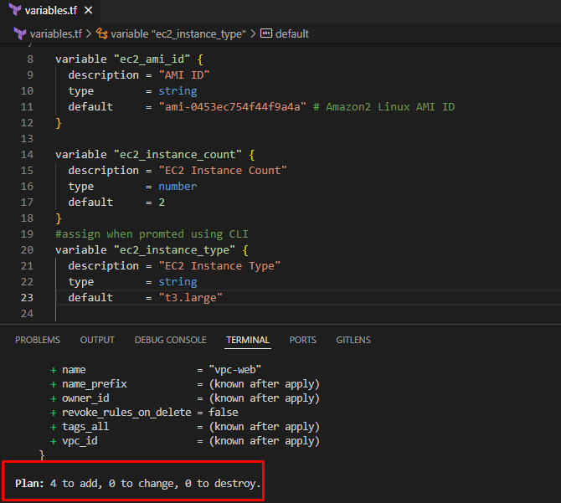

4 to add as 2 security groups and 2 instances. This is default.

**Input Variables Override with Environment Variables**

Set environment variables and execute `terraform plan` to see if it overrides default values

# Sample

export TF_VAR_variable_name=value

# SET Environment Variables

export TF_VAR_ec2_instance_count=1

export TF_VAR_ec2_instance_type=t3.large

echo $TF_VAR_ec2_instance_count, $TF_VAR_ec2_instance_type

# Initialize Terraform

terraform init

# Validate Terraform configuration files

terraform validate

# Format Terraform configuration files

terraform fmt

# Review the terraform plan

terraform plan

As we set the environment variables to 1 instance and changed the type to t3.large from t3.micro.

# UNSET Environment Variables after demo

unset TF_VAR_ec2_instance_count

unset TF_VAR_ec2_instance_type

echo $TF_VAR_ec2_instance_count, $TF_VAR_ec2_instance_type

terraform plan

